Profile Screen

Workshop #03

Flutter Developer Bootcamp

# **Purpose**

This workshop demonstrates how to create a profile screen to view the details of the user.

**Problem**

You want to create a profile screen. Your goal is to design a visually appealing layout with a floating action button , circular profile image, and icons aligned to the right side of the card widget.

**Here's your challenge:**

Create a profile screen for a social media app that includes:

* A floating action button positioned at the top right corner of the screen.
* A circular profile image centred at the top of the screen.
* Icons representing various actions (e.g., home,favourite,password & settings) aligned to the right side of the card widgets.

**How to Solve**

1. Checkout the workshop from Git Repo:

git clone -b <user-branch> <repo-URL>

2. Open the root folder inside VS Code

3. To build the app click the run option in the main method { }

4. Create a floating action button and display a circular image of the top of the screen

5. Add the corresponding icons on the card

# **You Will Achieve**

At the completion of the workshop, you'll receive a practical example demonstrating the construction of a profile screen in Flutter. This code furnishes essential UI elements, including an app bar, avatar, navigation cards, and interactive buttons for logout. It serves as a valuable resource for mastering widget composition, layout design, styling, and event handling in Flutter app development.

# **Screenshots**

## **Before implementation (without Image, Floatingactionbutton and Icons)**

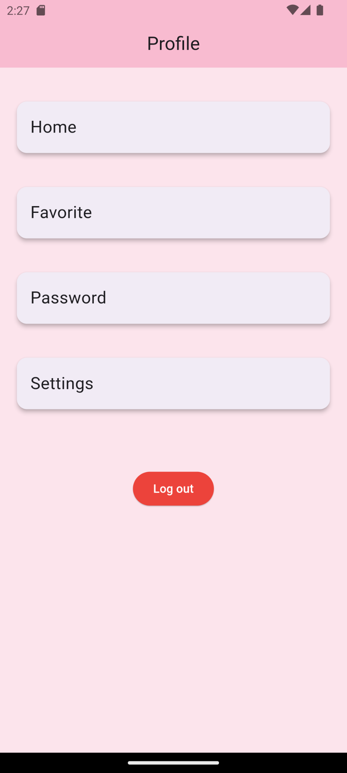

## **After implementation (With Image, Floatingactionbutton and Icons)**

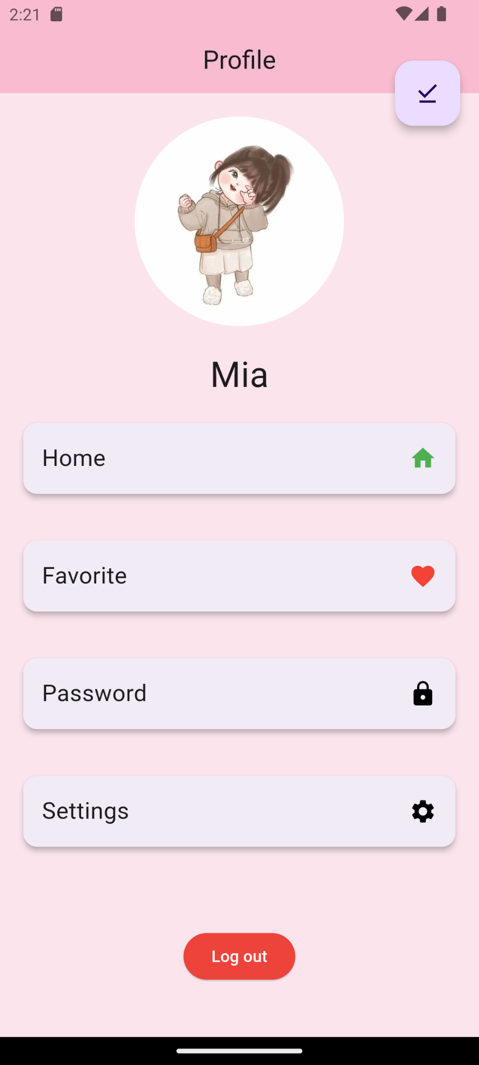

# **How to submit your workshop**

Push your project back to the same git branch using command:

<command name>

# **Happy Coding!**